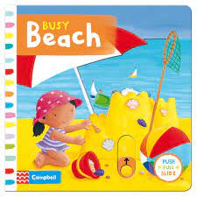

At the seaside
Summer 2 – Under 2’s
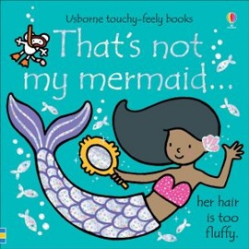
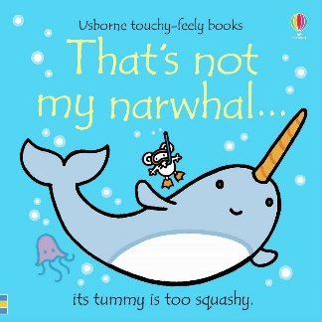
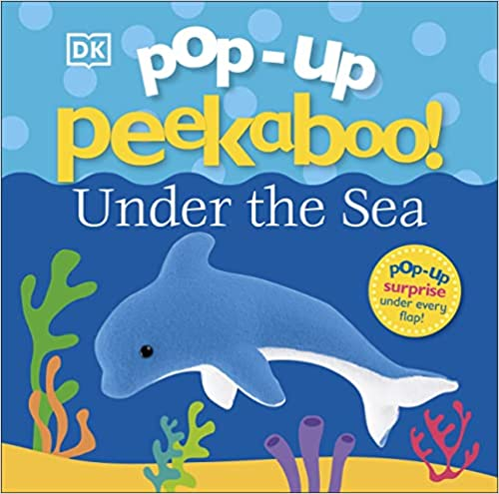
Half term plan
Busy beach
Pop up peekaboo -
‘Under the sea’
That’s not my mermaid
That’s not my narwhal

Vocabulary we are learning this term
Chocolate, strawberry, spoon,
water, mix, stir, spoon, juice, ice, cold,
splash, splosh, rough, hard, sand, ice cream, sun, rain, fish, splash, warm, pour, tip, sand, toes, feet, dry, rough, bucket, spade, paper, bumpy, paint, brush, up, down
To wash, to brush, to dry

Some of the Activities
*|Taste testing different flavours of yummy ice- creams
*Making juice ice cubes to taste
*Exploring sea side tuff spots using buckets, spades and sea creatures
* Exploring sand with our feet
* coloured water play outside
*Exploring paint outside using rollers, brushes and stampers to create different textures

