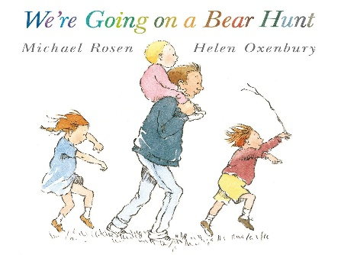

Half term plan
We’re going on a bear hunt
That’s not my Bear
Goldilocks touch and feel

Teddy Bear, Teddy Bear
Spring 2 – Under 2’s
Some of the Activities
*Share and take turns with teddies and food in the home corner
*We are going on a bear hunt outside stamping our feet in mud and walking through the grass.
* Building a Gruffalo house using natural materials
* Creating teddy pictures using a variety of materials can we plot the eyes, nose and mouth on our teddy bear.

Vocabulary we are learning this term
Bear, yummy, juice, tea, bowl, cup, spoon, mix, hot, blow, cold, grass, soft, mud, snow, water, wet, walk, coat, shoes, Teddy, bear, high, sky, mummy, daddy, baby, man, fingers, cat, owl, bird, leaves, tree, sticks, house, small, eyes, nose, big, small, mouth
To make, to put, to like/to love

