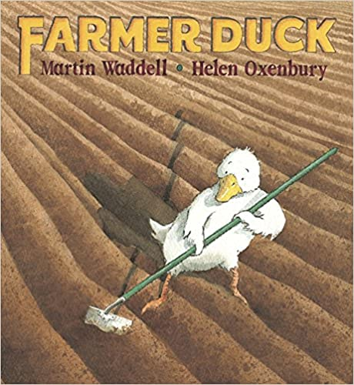
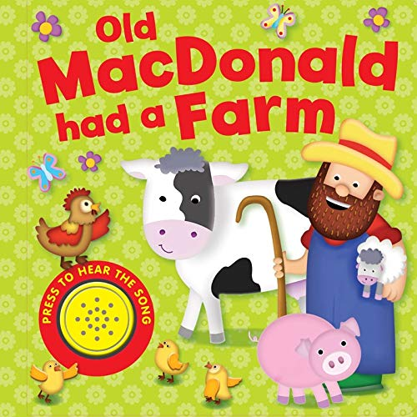
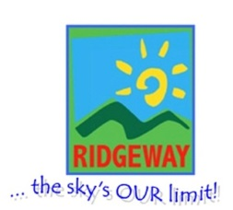
Half term plan
Old McDonald had a farm
Farmer Duck
That’s not my tractor
That’s not my piglet

Some of the Activities
*Tuff spot to explore and use our senses which includes shredded paper, twigs, grass and coco for mud.
*Puppets to sing songs and act out actions. Feel and explore puppets, making animal noises and learning animal names
*Creating animal masks suing materials and textures.
*Exploring pink shaving foam, pink playdough and pink gloop
In the farmyard
Spring 1 – Under 2’s
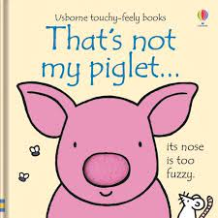

Vocabulary we are learning this term
Grass, soft, Twig, hard, mud, duck, pig, horse, sheep, frog, cow, dog, cat, meow, moo, quack, woof, wet, car, beep, quack, mummy, water, cups, big, stack, tower, high, soft, sticky, runny, fluffy
To look, to give, to find, to get, to come, to read

