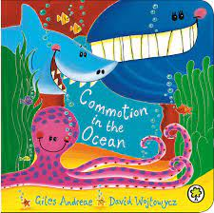

Under the Sea – Summer Term 2
Sunbeams Nursery & Sunny Days Pre-School

Week Plan
Commotion in the Ocean
Where’s the Starfish
Pirates Love underpants
Pirates – Non fiction
Ftaher’s Day
Summer

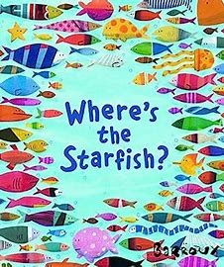

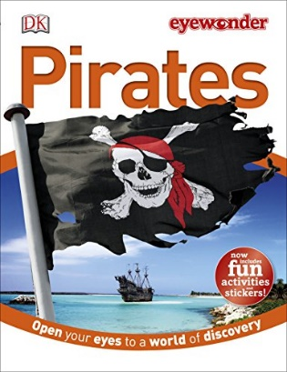
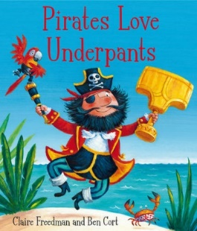
Vocabulary we are learning this term:
Commotion, behind, ocean, bury, jaws, iceberg, Treasure, anchor, elastic, map, quest, wade, Cutlass, olden days, eye patch, sailor, royal navy, skeleton
Reuse, cardboard plastic, waste, pollution, recycle, Gloomy, lawns, cannon, neighbour, uniform, friend
We will be focusing on
- Writing our names correctly
- Creating repeat patterns
- Drawing using lines and shapes
- Becoming independent with personal care
- Speaking in full sentences
- Listening carefully to instructions and stories
- Understanding and controlling our emotions
- Preparing for the transition into Reception

