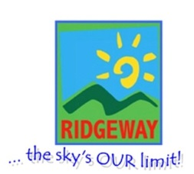
Dinosaur Roar
Summer Term 1
Sunny Days 2-3’s and Ridgeway Rainbow Tots

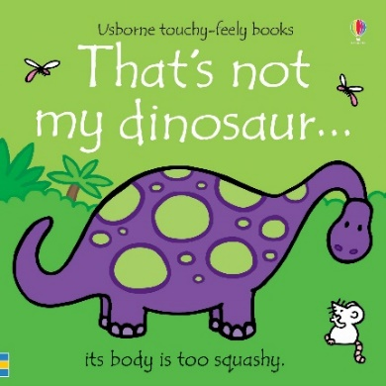
Half Term Plan

That’s not my dinosaur
Dinoesaur Roar
10 Little Dineosuars
King Charles’ Birthday/ British Values

Some of the Activities
- Creating playdough dinosaurs
- Using the instruments to make sounds while singing to ‘dinosaur dinosaur’.
- Making nature paper plate planets using things we’ve found in the forest school.
- Order dinosaurs in the classroom by size.
- Create own dinosaur picture of their favourite dinosaur in the story.

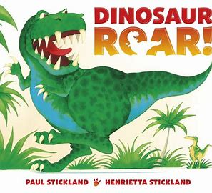

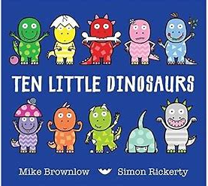

Vocabulary we are learning this term:
Squashy, teeth, bumpy, sharp, soft, hard, long, roll, flat, squeeze, Stomp, claws, jaws, snap, roar, Leaves, wet, dry, sticky, twig, branch, small, big, long, short, light, heavy, stomp, small, feet, tall, short, claws, spike, shiny, rough, rustle, leaves, noisy, quiet, roar, hiding, dirty

