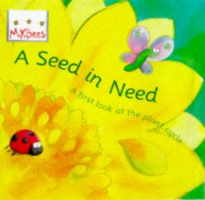
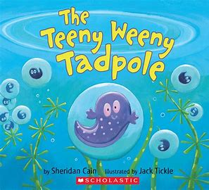
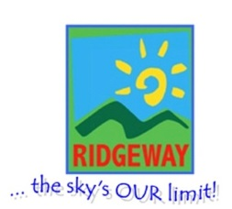
Half Term Plan
Caterpillar to Butterfly (non-fiction)
Little Red Hen
The Teeny-Weeny Tadpole
The Seed in Need
King’s Birthday/ British Values
Family Assembly

Out of an Egg – Summer Term 1
Sunbeams Nursery & Sunny Days Pre-School

We will be focusing on
- Colour mixing
- Writing our names
- Life cycles of frogs, plants, caterpillars and chickens
- Observing real eggs hatching, chicks, caterpillars and butterflies
- Understanding what plants and animals need to grow
- Making bread
- Investigating different types of eggs
- Careful counting
- Length, weight and size

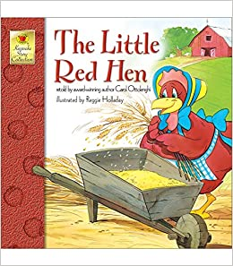

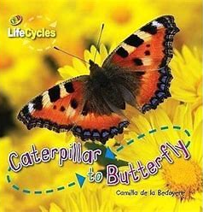

Vocabulary we are learning this term:
Hungry, life cycle, egg, cocoon, caterpillar, butterfly, Grains of wheat, bread, summer, thresh, mill, yeast
Amphibian, frogspawn, tadpole, froglet, hibernate, spring, Grow, shoot, nectar, roots, bud, seedling

