
What’s in the Garden
Spring Term 2
Sunny Days 2-3’s and Ridgeway Rainbow Tots

Half Term Plan

The Very Busy Spider

The Very Hungry Caterpillar

Superworm

Mother’s Day
Easter
Spring
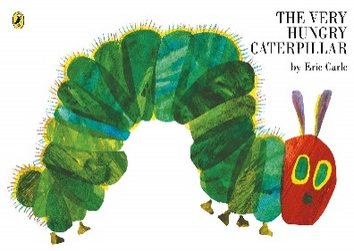

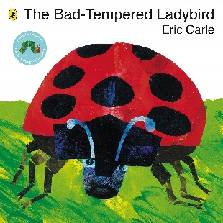
Some of the Activities
- Develop pretend play in the garden role play area
- Beginning to throw, kick and catch a ball outside.
- Use musical instruments to repeat patterns and sounds.
- Exploring the forest school looking for minibeasts
- Begin to compare amounts when looking at what the caterpillar ate in a week.
- Make a ladybird cupcake exploring the different senses.

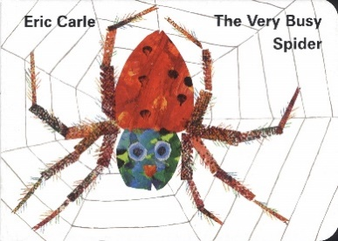
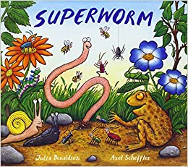
Vocabulary we are learning this term:
Garden, creature, flower, insect, spider, butterfly, caterpillar, roll, catch, jump, high, apple, strawberry, pears, plums, oranges, cake, ice cream, pickle, cheese, hungry, bugs, ladybird, worm, crawl, hit, bang, noise, sound, heavy, light, small, spots, mix, spoon, stir, pour.

