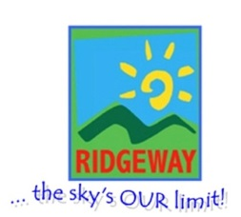
Journey to… another World – Spring Term 2 Sunbeams Nursery & Sunny Days Pre-School

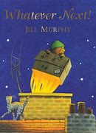
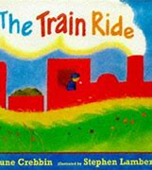
Week Plan
Whatever Next
The Train Ride
Journey Home from Grandpa’s
Mother’s Day
Easter
Spring

We will be focusing on
- Retelling longer stories using story language.
- Counting syllables in words.
- Using scissors and developing control.
- Talking in longer sentences and extending our vocabulary.
- Creating repeat patterns.
- Looking at differences in other countries.
- Showing emotions in our paintings.
- Using positional language.
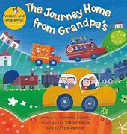
Vocabulary we are learning this term:
Moon, rocket, helmet, chimney, picnic
Foal, reflection, lighthouse, tractor, ticket, tunnel, Lost, coils, slither, wings, creature, discover, Journey, helicopter, track, crane, canal, barge, Untied, comet, pattern, planet, puncture, pizza

