
Down in the Forest
Spring Term 1
Sunny Days 2-3’s and Ridgeway Rainbow Tots
Half Term Plan
Where’s my Teddy?
The Gruffalo
We’re Going on a Bear Hunt
World Book Day
Winter

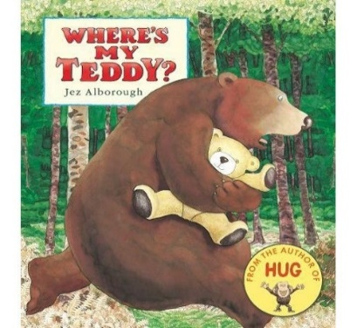

Some of the Activities
- Singing songs and nursery rhymes,
- listening to and repeating words from stories,
- building a house for the bears with blocks,
- going on a hunt around the forest school and bringing back items to create pictures
- enjoying stories with an adult

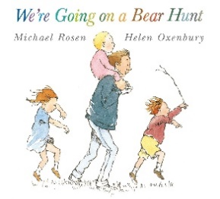
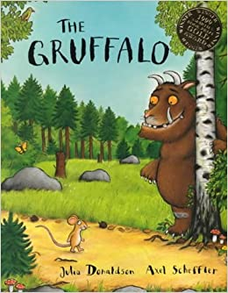
Vocabulary we are learning this term:
Mummy, Daddy, man, lady, brother, sister, baby, bear, eyes, nose, ears, box, small, tall, paint, stick, fox, mouse, mice, owl, owls, snake, small, big, fly, high, rain drops, planes, windy, clouds, sky, leaves, bugs, door, rain, wind, cold, hot, teddy, swing, bike, bricks, bus, car, doll, brush, pram/buggy, Door, rain, wind, sunshine, cold, hot, picnic, crunch.

