Happily Ever After – Spring Term 1
Sunbeams Nursery & Sunny Days Pre-School

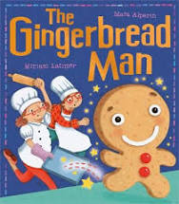
Half Term Plan
The Gingerbread Man
Humpty Dumpty
Jack and The Beanstalk
World Book Day
Winter


We will be focusing on
- Increasing our vocabulary to include story language
- Investigating different materials and what they are best used for
- Practising careful counting
- Retelling familiar stories using repetitive language
- Using our gross and fine motor skills
- Practising using scissors carefully and with control
- Talking about how different characters feel in the stories we read.

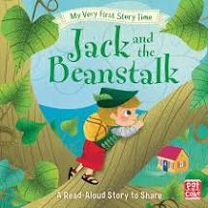
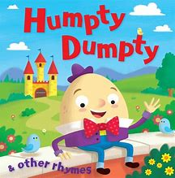
Vocabulary we are learning this term:
Baker, oven, ginger, sly, hungry, heavy
Wall, fall, pieces, together, positive
Market, beanstalk, castle, enormous, safe, poor

