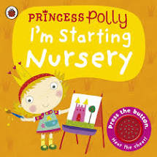
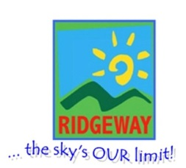
People Who Help US – Autumn Term 1 – Sunbeams Nursery & Sunny Days Pre-School
Half term plan
Getting to know your children
Life is a Rainbow
What does chef a do?
What does a police officer do?
What does a vet do?

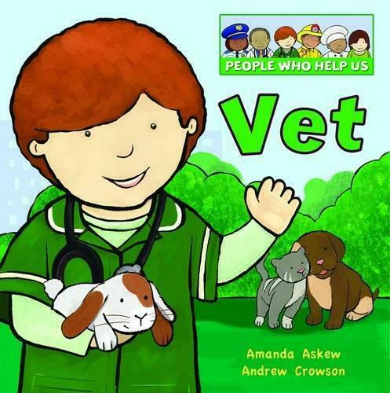

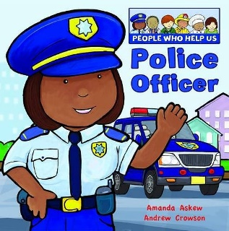

Some of the Activities
Writing our names, counting groups of objects, recognising colours, making pictures with shapes, learning to wash our hands, using scissors to makes snips in paper, painting pictures, exploring the garden, climbing on the climbing frame, making new friends, listening to stories, learning to put our coats on. HAVING FUN!
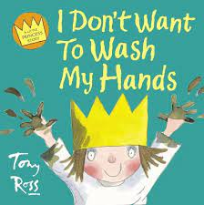
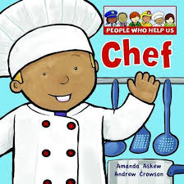
Vocabulary we are learning this term:
Heart, excitement, calm, feelings, scared, Clinic, hibernating, vaccination, patients, x-ray, operation, Chef, restaurant, prepare, menu, recipe, ingredients, Crime, police station, uniform, patrol, radio, siren

