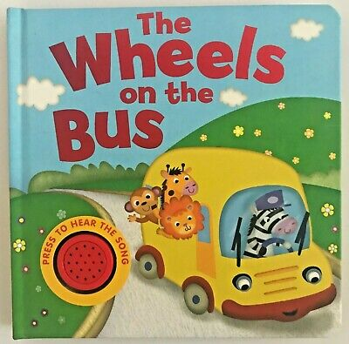
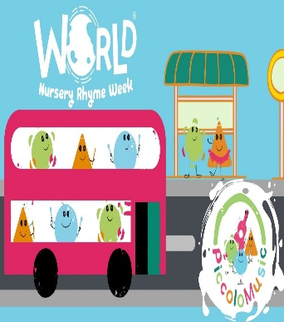
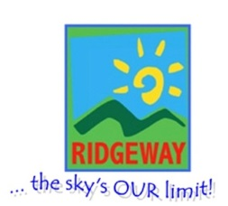
Some of our Activities
*Singing nursery rhymes joining in with songs and actions
*Wheel print painting
*creating a bus using shapes
* Building a rocket using blocks
* foot print rocket craft
*Christmas craft including cards, calendars and winter sensory play

Weekly book focus
That’s not my bus
World nursery rhyme week
That’s not my car
Wheels on the bus
Let’s Fly
Christmas

Let’s get Moving
Autumn 2 – Under 2’s
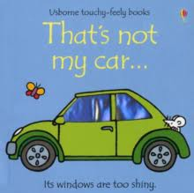
Vocabulary we are learning this term
Boat, water, car, bike, house,
duck, truck, bus, wheels, rockets, sky, fly, ball, in, out, box, pencil, paper
To run, to push, to kick, to hit, to throw, to push

