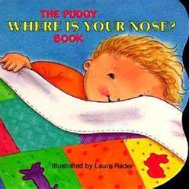

Half term plan
Welcome everyone
Where is your nose?
If your happy and you know it
Ten little fingers and ten little toes

Some of the Activities
*Joining in with play engaging with others and making new friends
*Using musical instruments to explore sounds. Can we join in with music and move our bodies.
* Join in with songs and rhymes learning new vocabulary and songs
*Explore messy play using tools and our bodies.
*follow instructions given by adult copy and repeat actions to music and songs

Me, Myself and I
Autumn 1 – Under 2’s
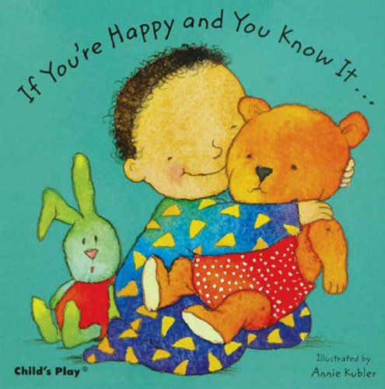
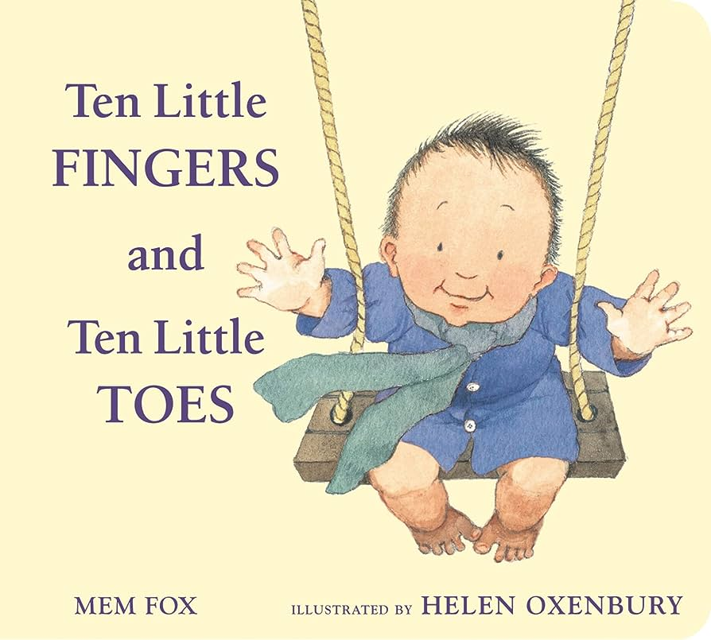
Vocabulary we are learning this term
Noise, loud, quiet, dirty, hot, cold, doll, pram/ buggy, gone, more, yes, no, book, build, join, in, out, bricks, Nose, eyes, ears, head, toes, hair, hands, mouth, tummy, up, down, on, Bag, coat, hat, dress, pants, shoes, socks, trousers
To clap, to sit, to stand, to look, to play, to walk, to wash, to brush

